HTTP Application Layer

The **Hypertext Transfer Protocol** (**HTTP**) is an [application protocol](https://en.wikipedia.org/wiki/Application_protocol) for distributed, collaborative, [hypermedia](https://en.wikipedia.org/wiki/Hypermedia) information systems.[[1]](https://en.wikipedia.org/wiki/Hypertext_Transfer_Protocol#cite_note-ietf2616-1) HTTP is the foundation of data communication for the [World Wide Web](https://en.wikipedia.org/wiki/World_Wide_Web), where [hypertext](https://en.wikipedia.org/wiki/Hypertext) documents include [hyperlinks](https://en.wikipedia.org/wiki/Hyperlink) to other resources that the user can easily access, for example by a [mouse](https://en.wikipedia.org/wiki/Computer_mouse) click or by tapping the screen in a web browser. (Wikipedia)

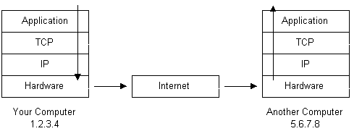 (Standford)

The sender of the information was IP Address 172.16.16.128 aka Chris Sanders on port 1989, the receiver was IP Address 69.163.176.56 and was a webpage known as [www.chrissanders.org](http://www.chrissanders.org) on port 80. Chris was trying to post a comment “THIS IS A POST TEST” to the comment section of his website. It took roughly 1124 bytes or rather 1.1 kilobytes using TCP in order to post the information which was 179 bytes total. 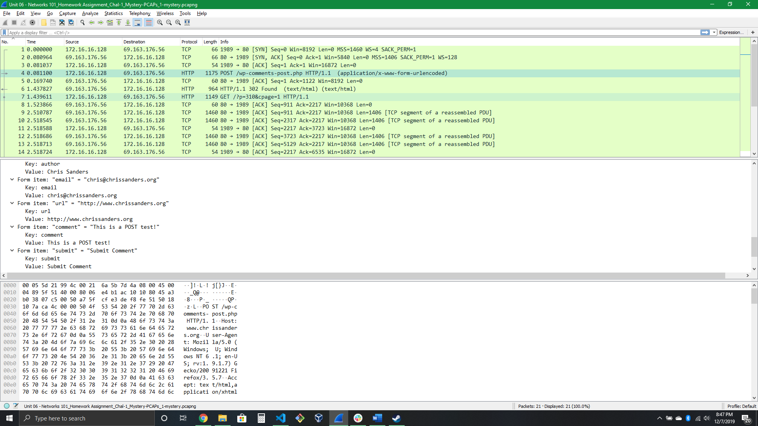 The Website then used TCP to push 910 Bytes back to Chris. Then Chris wanted to view information about himself so he navigated to the about section on his website. His request was 1.095 Kilobytes.

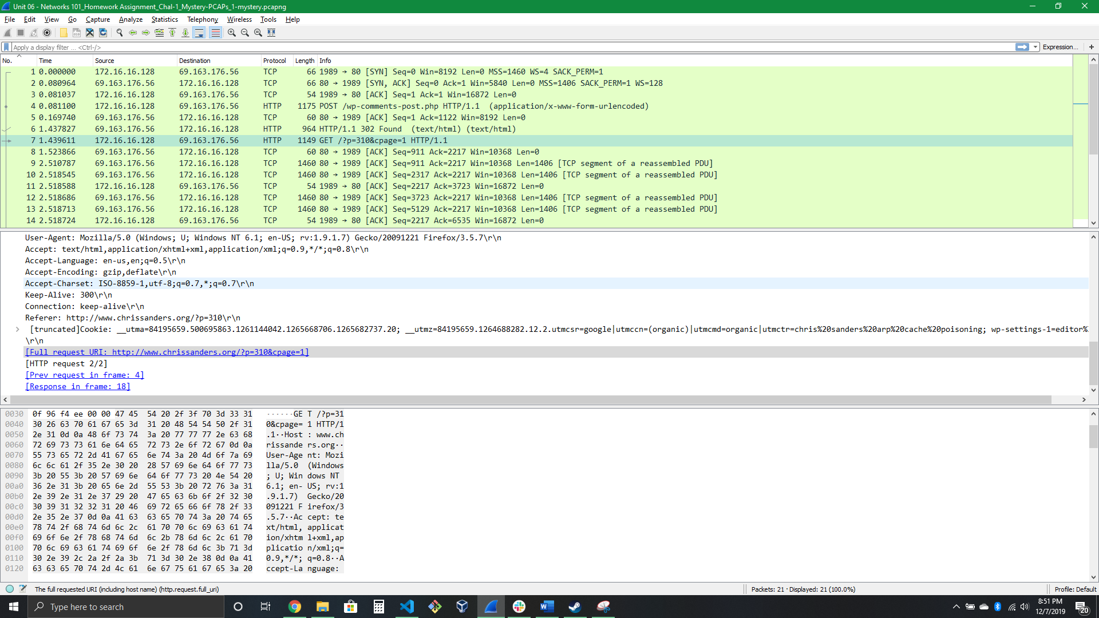

The data that was transmitted was the entire HTML Webpage from the about link. The TCP data was 265 Bytes and the HTML Data was 40327 bytes or rather 40.3 kilobytes.

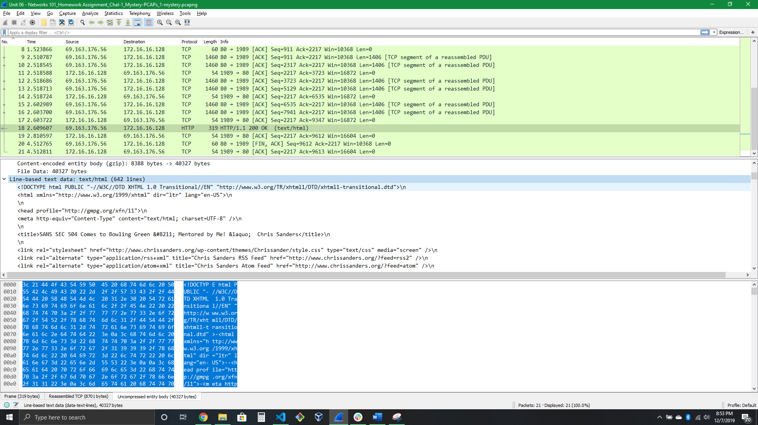

And this is what the webpage actually looks like.

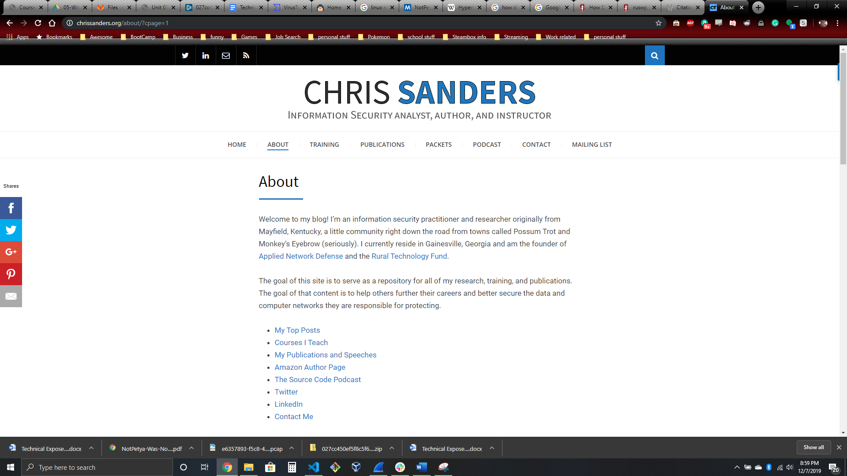 (ChrisSanders)

# References

Wikipedia, Hypertext Transfer Protocol. (2019, December 5). Retrieved from <https://en.wikipedia.org/wiki/Hypertext_Transfer_Protocol>.

Stanford, Shuler, R. (2002). How does the internet work. Retrieved December 7, 2019, from <https://web.stanford.edu/class/msande91si/www-spr04/readings/week1/InternetWhitepaper.htm>.

Chris Sanders, About, (2018, May 16). Retrieved December 8, 2019, from <https://chrissanders.org/about/?cpage=1>.